PEGASUS U3A GEOLOGY/BOTANY GROUP May 2025 Newsletter
Hello Everyone,
I’m sorry we had to cancel the Quail Island trip, but the weather was very iffy and we might enjoy the outing more if we can schedule it later in the year. The next trip to see ferns with Graham Worner is limited to 20 and there are 3 places left. Let me know if you would like them. No meeting in June as it’s King’s Birthday weekend

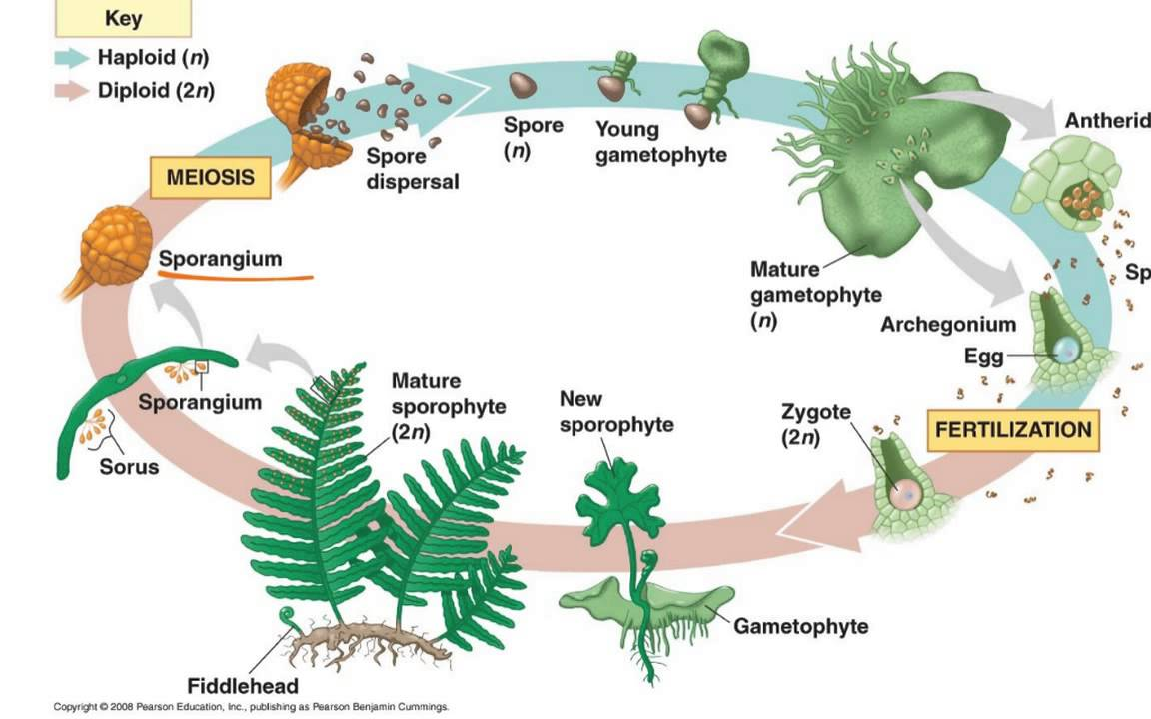
Recent talk. 5th May New Zealand Ferns and their Propagation Graham Worner
sperm
Graham started with a diagram showing the stages of development from spore to fern plant. It takes 4 months to go from a spore to a gametophyte, a microscopic stage. There are millions on the forest floor. On the underside there are male and female sex organs and fertilization takes place when sperm from another fern swim to the female egg. This gives 4 chromosomes for development into zygote, division of cells to embryo, then a shoot (sporophyte) appears and the fern grows. This is why ferns flourish in wet conditions, sometimes on the South side of trees where water drips.
Graham went on, alas without his slides, to explain the propagation which he helps Fern Factor to do. It starts with cleaning the underside of a frond with spores. They fall off and explode as dust out onto paper. They are packeted up and put in the fridge. Later they are put in water and about 90% germinate. They are then put onto sealed green trays with controlled light and water. Later with tweezers they are potted into small plug pots and then grown on till big enough to sell in 10cm pots after a year. It takes another year for them to double in size and price.
Graham also undertakes research projects to try to maximize fertilization and development. They are trying different growing mediums as peat is not environmentally good. Coir was tried but was not as good as peat.
It will be interesting for some of us to go and see the process in action on our next trip.

Next Trip
Wed 21st May We will car pool at 9.30, McCormacks Bay Road or meet at Graeme Worner's place at 10am, 1472 Springs Road. He has requested that cars angle park outside his home. Bring a flask etc. for morning tea which we can have there. We will be there for approximately 40mins, then we will travel to Fern Factor on Newtons Road. There is no street number, but we can follow Graeme there. There is a yellow letter box outside the property.

No meeting in June as it’s King’s Birthday weekend

The Geo/Bot subgroup meets at 10am on the first Monday each month at Club Redcliffs in James St.
Our bank account is U3A Botany/Geology 03 1599 0139475 000.
You can contact me on 384 3475 or by email patwandpate@gmail.com

