1st April Opal Mining Jim Begg

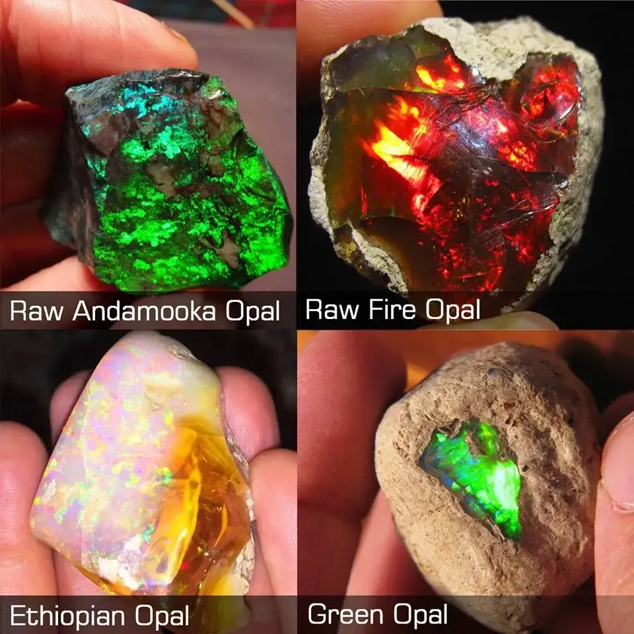
Jim told us about his interesting life as an opal miner. He teamed up with a variety of people in Lightning Ridge and Coober Pedy. The fortunes of an opal miner go from unearthing a $30,000 stone one day to a couple of barren years when nothing worthwhile is found. It is a hard life in unfriendly surroundings, hot and sweaty manual labour and makeshift machinery but Jim made it interesting as well as informative describing gadgets created and personalities he’s worked with.

