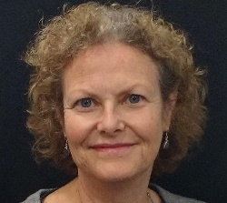
!9th June The Ethics of Memory Judith Coullie
Our guest speaker was Judith Coullie who began her address with a question.
“When is remembering or forgetting right or wrong?”
Ethics, she explained, examines the rational justification for our moral judgements.
Memory is the basis of all knowledge so we hope to remember accurately and be able to retrieve our memories. Memory is like a net full of fish but masses of water has poured through it without sticking. The present is a collage of past memories which shapes our behaviour, opinions, fears, likes and dislikes.
Memories ground us in our social position and give us significance. We want to be remembered. Memory of history also establishes national values. Creeping determinism allows us to reinterpret the past and adjust memories to make them more comfortable. Nostalgia is like a grammar lesson. We find the present tense but the past perfect. We get good feelings from happy memories.
Judith gave us three examples of the ethical use of memory.
1. When border control eased in South Africa in 1994 many refugees were unaccompanied children. They were given suitcases to decorate and fill with their writings and paintings to give them a sense of identity.
2. Many adolescents were orphaned when parents died of AIDS. Camps are held where they engage in storytelling and this builds resilience and healing when they talk about the past, present and future.
3. Sinomlando, means “we have history”. A series of oral history projects to help children and caregivers and a counsellor build memory boxes. They are filled with stories of where they came from, memories of parents, family history and photos. This is still happening.
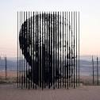
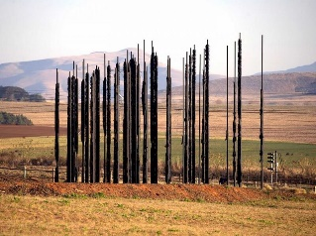
Judith finished by talking about the Truth and Reconciliation Commission in South Africa after apartheid was over. 22,000 people were allowed to testify about abuse. Of the 7,000 abusers 1,500 were granted amnesty. Desmond Tutu said that ”There is no future without forgiveness”
On the left is the Nelson Mandela sculpture made of 50 steel columns, commemorating 50 years since his capture. The image can be viewed from two separate directions. The extreme left is one view, and the one above showed Mandela’s face. Amazing;l

