PEGASUS U3A GEOLOGY/BOTANY GROUP July 2023 Newsletter

Hello Friends,

This morning there was bright sun when I went to get the paper but it didn’t last long. In some ways it’s quite nice being able to hibernate and watch the dog owners scurry past in the rain. There’s time to read a book, play computer games or even work on a difficult jigsaw I was given for my birthday without feeling guilty about the gardening. The weeds will be making the most of this freedom! I hope you are all keeping warm and enjoying it too.

Recent trip
21st June Christchurch Adventure Park

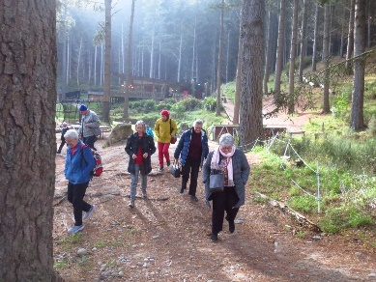
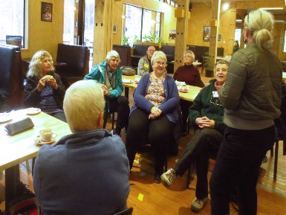

Our trip to the Christchurch Adventure Park started in the café where we heard all about the place from Mel, a member of staff. McVicars own the land and shareholders own the facilities with the City Council holding 40%M Mc

The Christchurch Adventure Park was built by a Canadian company from Whistler and opened in December 2016 with 5 tracks. It had to shut after 4 weeks because of the fire and reopened 10 months later. After 2 years, Covid arrived and it was shut again for 6 weeks but re-opened at Level 2. The open side of the area is still quite bare and the 48 trails are mostly through the areas with trees. The trails are colour graded from green for beginners up to double black for the experts, with rocks and jumps along their way.
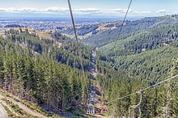
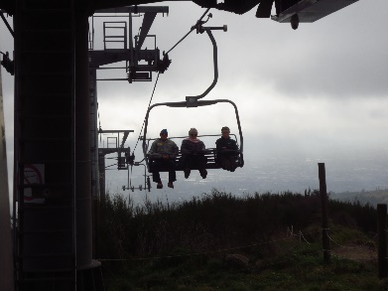
The chairlift is 1.8 km long and goes right to the top of the hills so you can see down Lyttelton Harbour on arrival. The gentle ride goes over areas of gorse and banana passion fruit and several chasms and cliffs and the speed can be slowed right down to help people on and off. Between each set of chairs is a bike rack so cyclists can take their bikes up to the top and ride down. Operation of the chairlift is weather dependent with wind constantly monitored at the top and bottom. Any lightning must be 30km away. If you walk or bike up you can have a free ride down. It is busiest at weekends but not so busy when it’s snowy as many cyclists are also skiers. Staff numbers triple in summer to 16. The Park’s other international attraction is a set of 4 ziplines but we didn’t see them.
They are very safety conscious and have medics on hand all the time and plans for getting people off the chairlift if it ever gets stuck. It Hasn’t done so far. Trail maintenance is constant with regular daily inspections.
We thoroughly enjoyed our visit and the ride and would encourage anyone to do it on a fine day. Only $15 for pensioners or a 10 ride up pass for $100 for other people. Maybe a useful gift idea for your families?
Thanks to Gill Fountain for the idea and organization.

Recent talk
3rd July The Life and Afterlife of Plastic Prof Ian Shaw

Professor Ian Shaw after working in many universities worldwide is a professor of Toxicology at Canterbury University. He has had many years researching food safety and has written many books and academic papers. He received the 2009 NZ Association of Scientists Communicator’s Award and the Canterbury Students’ Association Science Lecturer of the Year in 2009, 2013, 2014, 2016 and 2020, and Supervisor of the Year in 2018.

Almost everything around us is made of plastic these days. It is indispensable, plastic fantastic. Production worldwide has increased from the 1950s and now 600 million tonnes is produced each year. We can see discarded plastic along our roadsides and on beaches where it breaks down into small particles and microplastic.

Polystyrene is a major problem. It is made from molecules of styrene which clump together in a hexagonal pattern. When this breaks down styrene is released. It is toxic and bonds to DNA, and all fat cells contain styrene. The poorer quality polystyrene, made abroad, releases more toxicity as it breaks down.

Microplastics ranging in size from 1.6µm (a thousandth of a mm) to 10mm are found in the sea from Lyttelton Harbour to the Antarctic. 55% of our microplastics come from polystyrene in NZ. These molecules attract pollution like DDT and other carcinogens. Mussels and fish consume them and feel full, but lack of nutrients in this diet causes eventual death from starvation. Even green leaves can contain traces of microplastics. In our gut they cause inflammation and the carcinogens lead to cancer in the grooves of our intestines.

Plasticizers are added to some polystyrene to make it more pliable. They link clumps of polystyrene molecules together so there is some freedom of movement. They are also toxic and have been used in cleaners like Mr. Muscle, (now banned). Their molecule chain refolds itself to resemble the female hormone oestrogen.

Polycarbonates are another type of plastic used in drink bottles, greenhouses, CDs and a coating on supermarket bills. The chemical is bisphenol A and can leak into food. It links to the oestrogen receptors and causes feminization in humans and other creatures. Oysters can change sex but if all become female no breeding takes place. Alligator penises are shorter, girls are reaching puberty earlier, the sperm bank has problems….

Some plastics are good and should be retained. Hygienic food packaging is essential, but biodegradable sorts should be used. Disposable surgical instruments are necessary to avoid post operative infection. Infection soars in countries that reuse them. We do need to recycle, educate people and find sustainable alternatives. The benefits must outweigh the risks. For our generation the impact is small and we should continue to eat well, but future generations may have a bigger problem.

Ian made a rather complex and dire topic very entertaining as well as informative and easy to understand.

Future Events

Wed 19th July Graham Harrington will take us to some sites on the Styx Mill River. From the car parks we’ll take a very short walk down to the lakeside to see the bird life and I’m hoping someone from the Styx Mill Living Laboratory will meet us there for a short talk. Those with cell phones that read QR codes might like to go to a bridge where they can use them to see the life under water. Bring your lunch and we’ll drive a short distance to the Redwood Springs where there is good seating. After lunch, depending on how people feel, we can go on to another part of the reserve where Graham will tell us about the waterworks or take a short drive to see a Māori installation called the Talking Stones. We’ll decide on the day.
Car pool in MccCormacks Bay Road at 10.30 or meet there at 11.15. To get to the right entrance to the Styx Mill Reserve, drive along Cranford St. Use the left lane to avoid the motorway. Right into Main North Road. Left into Styx Mill Road. Pass the Metro Station on the right. At the 2nd 60kph sign turn right into a driveway. There are lots of parks a short way inside. If you pass Cavendish Road on the left you’ve gone too far.

Monday 7th August Melissa Hutchison will give a talk on Lichens.
Wednesday 16th August A visit to Ambrosia Nursery at Prebbleton
Monday 4th September A talk by Zane Lazare about the Red Zone
Wednesday 20th September A trip to see the Lincoln magnolias and Lincoln landscaping

You can contact me on 384 3475 or by email patwandpate@gmail.com

